**Selenium Grid**

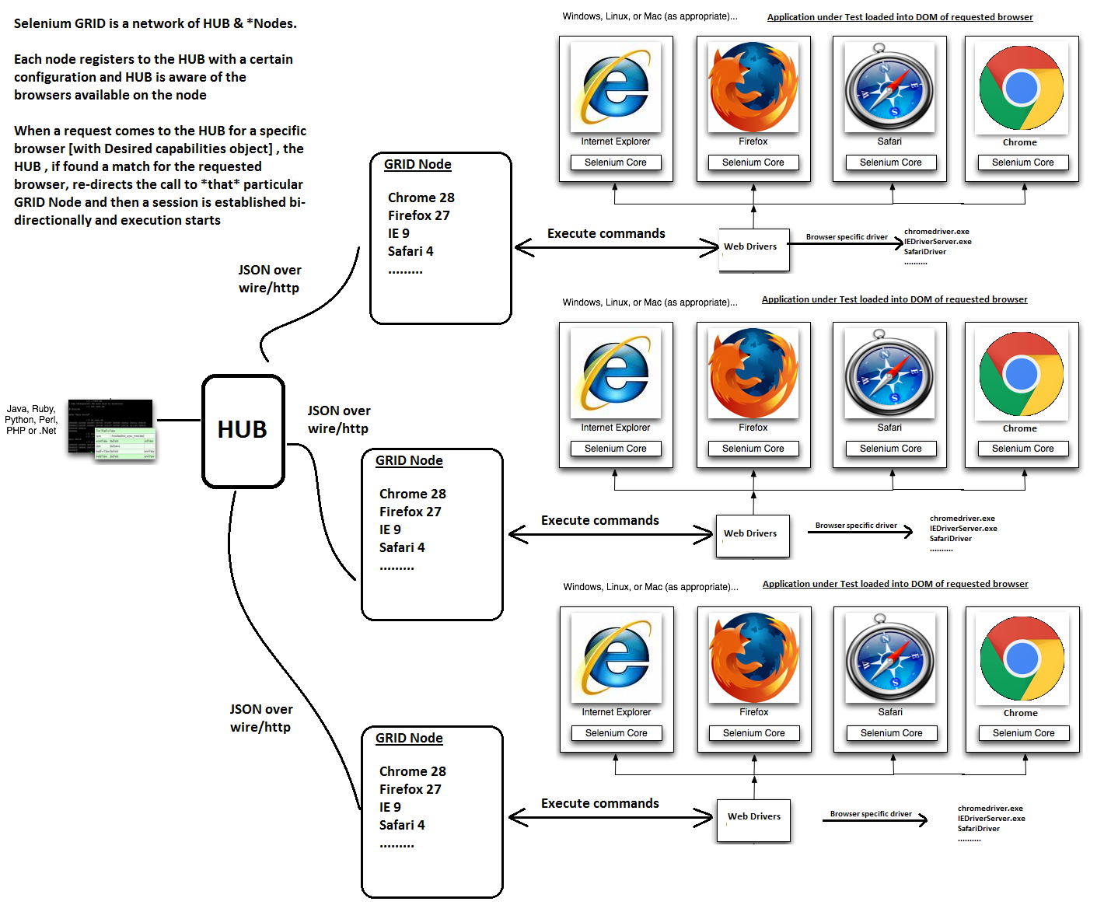

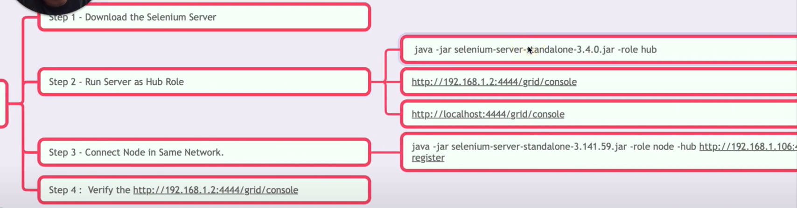

**Before running hub check below url**

<http://localhost:4444/grid/console>

**To start hub:**

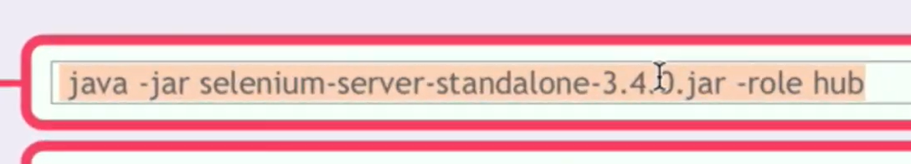

java -jar selenium-server-standalone-3.141.59.jar -role hub

**To register Node:**

java -Dwebdriver.chrome.driver=”D:\RBA Infotech\4. Course Contents\Testing Full Stack\JAR Files\drivers\chromedriver.exe” -jar selenium-server-standalone-3.141.59.jar -role node -hub <http://192.168.0.109:4444/grid/register/>

Node

Hub

java -Dwebdriver.gecko.driver=”D:\RBA Infotech\4. Course Contents\Testing Full Stack\JAR Files\drivers\geckodriver.exe” -jar selenium-server-standalone-3.141.59.jar -role node -hub <http://192.168.155.99:4444/grid/register/>

**To executed parallel test**

java -Dwebdriver.chrome.driver="D:\RBA Infotech\4. Course Contents\Testing Full Stack\JAR Files\drivers\chromedriver.exe" -Dwebdriver.gecko.driver="D:\RBA Infotech\4. Course Contents\Testing Full Stack\JAR Files\drivers\geckodriver.exe" -jar selenium-server-standalone-3.141.59.jar -role node -hub http://192.168.239.99:4444/grid/register/